It’s Time for Us to Design Your IVP Cover!

You’ve made a lot of progress on your manuscript. Congratulations! We’re now at a point where the IVP design, sales and marketing teams are beginning to do advance work on your book’s release. That process begins with settling on a title and designing a cover.

Settling on a Title
The best titles clearly communicate the topic of their book. A title doesn't have to tell you everything; it just needs to entice the intended audience to read more—and of course, the more central or core to the content of the book, the better.

Of course, a book’s title is also an opportunity to get creative, to appeal to a reader’s sense of imagination. We strive for creative, content-rich titles, and we’ve had some great success. But in the contemporary reading marketplace, where readers shop for books by key words and booksellers organize books by author last name, content trumps creativity. It is, in fact, almost always a bad idea to go with a purely creative title for a nonfiction book. So a good rule of thumb is this: if you have two titles and one is purely evocative but the book’s content is obscured or absent, while the other is full of content but dull, choose the dull title.

Please answer the following questions to inform our title brainstorming process:

Your current book title: Your name:

- Who is your audience? Describe your most likely reader (the core audience), and the readers one and two tiers beyond that (the secondary and tertiary audiences).
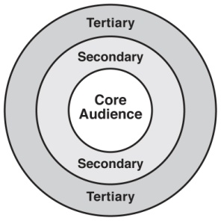

- How would you describe your book to a curious potential reader? Limit yourself to fifty words, and try to seal the deal!

- What are some key themes in your book?

- What are some keywords people would most likely use in a search for a book like yours?

With your input, IVP’s sales, marketing and editorial professionals will brainstorm a title to help your book find its audiences in a crowded marketplace. You should hear from us on a title within a month.
Designing a Cover
Once a book’s title has been finalized with the author, the editor and key members of the sales and marketing departments meet with the IVP design team to discuss the book’s uniqueness, its intended audience and the desired cover “feel,” and comparable books or genres to give the design team a framework for exploring creative possibilities for your cover. Our design team will then mock up several possible designs for your book, taking into account content and genre, as well as the profile of your main audiences and the various “gatekeepers” (booksellers, book reviewers, etc.), and the design “code” established by comparable books in the marketplace. The design team works within schedule and budget constraints for the 90-100 new covers they design each year.

Next, your editor and key members of the sales and marketing departments will then review the possible designs and present you with the cover that best addresses audience, content, genre and gatekeepers, in order to gain the widest possible hearing for the book.

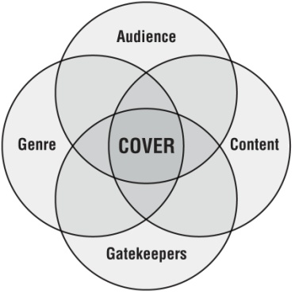

To help us in this process, please respond to the following questions:

- What books are currently in the marketplace that you think fit the audience of your book and cover similar ground to yours? (Please list at least three books.)

- What books currently in the marketplace have covers that you particularly like? (These may or may not overlap with question 1.)

- How do you see your book as distinct among those other books?

- How would you describe the “feel” or “vibe” of your book (for example, welcoming, soft, subtle, contemplative, serious, practical, assertive, playful, skeptical and so on)?

- Are there ways you worry your book could be misunderstood? Overused images related to your topic?

- Anything else you’d like us to be thinking about as we select a cover for your book?

Thanks for your help as we develop the title and cover for your book! We look forward to presenting you with a cover designed to help your IVP book reach its broadest possible audience!

